 Wellness House Referral Form
Wellness House offers an extensive range of programs for practically every aspect of living with cancer, from support and connection with others, to nutrition classes and exercise. All staffed by experts in their fields, our programs take place all day nearly every day of the week. Family members are encouraged to attend programs as well.
Wellness House will not share your name or information with any other person or outside organization.
Date___/___/___

How can Wellness House help you?
o Individual Counseling o Support and Networking Groups
o Stress Management o Children/Family Programs
o Healthy Living: Nutrition____ o Programs that provide information and education
Exercise___ o Wigs and/or personal appearance
Mind/Body__ o Community resources
o Other, please specify_______________________________________________________

o Yes o No I have participated in programs at Wellness House before.

Your Information
o I am the person diagnosed with cancer
Primary cancer type__________________
Date of diagnosis _____/____/__________
o I am family member or friend of someone with
cancer

o I am a professional caregiver
Primary Language: o English o Spanish o Other

Name __________________________________________
Address_________________________________________
City__________ State__________ Zip_______________
DOB: / /______ Gender______ Race_________
mo. day year
Preferred phone number___________________________
Email address___________________________________
Primary Oncologist: ______________________________ Hospital:_____________________________
Preferred method of contact: o Phone (May we leave a message? Yes No) o Email
o I consent to being contacted by a Wellness House staff member for information about Wellness House programs and support.
o I agree to the exchange of relevant information about me between the referral source and Wellness House

Signature__________________________________________

Staff Signature if verbal consent provided ____________________________________________

Please return forms to: Marci Goldberg, Participant Engagement Coordinator
mgoldberg@wellnesshouse.org or fax to 630-654-5345.
Ekingii@wellnesshouse.org or fax to 630-654-5345. Earl can be contacted by phone at 630-654-7203.
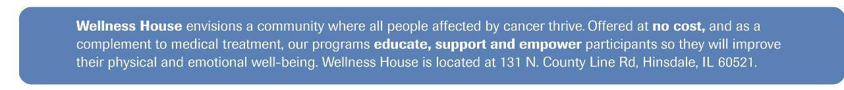
awenclawski@wellnesshouse.org or fax: 630-654-5345

